An Internship Report
on

“Green Skills and Artificial Intelligence”
Submitted to the
Savitribai Phule Pune University
In partial fulfillment of

“Artificial Intelligence and Data Science”
By

Paras Rahul Pingale - 32552.

Under the guidance of

Name of Guide: - Prof. Priti Malkhede



Department Of Artificial Intelligence and Data Science
PES’s Modern College of Engineering
(An autonomous institute affiliated to Savitribai Phule Pune University)
Shivaji Nagar, Pune-411005, Maharashtra, India
2025-2026

CERTIFICATE

This is to certify that the internship report entitled “Green Skills and Artificial Intelligence” being submitted by Paras Rahul Pingale (32552) is a record of bonafide work carried out by him/her under the supervision and guidance of Prof. Priti Malkhede partial fulfillment of the requirement for TE (Artificial Intelligence and Data Science) – 2020 course of Savitribai Phule Pune University, Pune in the academic year 2025-2026

Date:
Place: Pune

Prof. Priti Malkhede Dr. Prof. Mrs. Shraddha. V. Pandit
Guide Head of the Departme

ACKNOWLEDGEMENT

I would like to take this opportunity to express my gratitude towards all those who helped me in accomplishing this internship work. First, I would like to thank P. E. S.'s Modern college of Engineering for giving us this opportunity to look in some concept apart from my curriculum subject. I would like to thank my guide Prof. Priti Malkhede mam for her valuable comments and timely support. I would like to show my greatest appreciation to her.
I would also like to express my sincere gratitude to the Principal Dr. Prof. Mrs. K. R. Joshi madam and the Head of the Department Dr. Prof. Mrs. S. V. Pandit madam for their valuable guidance, encouragement, and support throughout the completion of this work. I am equally thankful to all the faculty members for supporting me directly and indirectly. The guidance and assistance provided by all the Professors have been instrumental in the successful completion of this work. Lastly, I extend my heartfelt thanks to my friends for their continuous support and motivation.

Paras Rahul Pingale - 32552

Report Index

Sr. No. | Title | Page No.
1 | Abstract | 6
2 | Chapter 1: Overview | 7-8
 | 1.1 Introduction | 7
 | 1.2 Objective and Scope | 8
 | 1.3 System Requirement | 8
 | 1.3.1 Hardware Requirement | 8
 | 1.3.2 Software Requirement | 8
3 | Chapter 2: System Analysis | 9-10
 | 2.1 Requirement | 9
 | 2.2 Feasibility | 10
4 | Chapter 3: Software Design | 11 -13
 | 3.1 System Flow | 11
 | 3.3 Use Case Diagram | 13
5 | Chapter 4: Modules | 14
6 | Chapter 5: Final Analysis | 15 -16
 | Conclusion | 17
 | Bibliography | 18

List of Figures

SR. No | Figure Name | Page Number
1 | System Flow of Plant Disease Predictor | 11
2 | Data Flow Diagram Level 0 | 12
3 | Data Flow Diagram Level 1 | 12
4 | Use Case Diagram | 13

ABSTRACT
This project, developed during the Green Skills and Artificial Intelligence internship, focuses on the critical intersection of agricultural sustainability and deep learning. Current global food security is heavily threatened by crop diseases, which can reduce yields by up to 40% if not identified early. Traditional manual identification is often slow, inaccurate, and leads to the over-application of chemical pesticides.
To address this, I developed an end-to-end Automated Plant Disease Prediction System utilizing a Convolutional Neural Network (CNN). The system features a robust technical stack comprising a responsive frontend for image acquisition and a high-performance backend (Flask/FastAPI) for model inference. By processing leaf imagery—specifically through resizing, normalization, and tensor conversion—the model achieves high-precision classification across various plant species and disease types.
The "Green" Impact: The primary objective of this project is to promote Precision Agriculture. By providing farmers with immediate diagnostic results and targeted organic remedy suggestions, the system significantly reduces the "blind" application of broad-spectrum chemicals. This not only lowers operational costs for farmers but also minimizes soil toxicity and groundwater contamination, directly contributing to the United Nations’ Sustainable Development Goal of Responsible Consumption and Production (SDG 12).
The results demonstrate that AI-driven diagnostics can serve as a scalable, cost-effective tool for sustainable farming in the digital age.
Keywords: Sustainability & Agriculture, Transfer Learning, Automated Diagnostics, Full-Stack ML Integration, Dataset Optimization

Chapter 1: Overview

1.1 Introduction
The modern agricultural landscape is currently facing a dual crisis of declining food security and increasing environmental degradation, necessitating a shift toward Agriculture 4.0 through the integration of Green Skills and Artificial Intelligence. This project addresses the critical challenge of crop loss due to pathogens—which currently accounts for significant global yield reductions—by deploying a Deep Learning-based Automated Plant Disease Prediction System. By utilizing Convolutional Neural Networks (CNNs) to analyze foliar imagery, the system bridges the gap between expert phytopathology and field-level farming. This digital intervention replaces traditional, subjective visual inspections with high-precision, data-driven diagnostics.
From a sustainability perspective, this project serves as a cornerstone for Precision Agriculture; by providing farmers with immediate, accurate identification of diseases and specific organic remedy suggestions, it actively discourages the "blind" or prophylactic application of broad-spectrum chemical pesticides. This targeted approach not only optimizes operational costs for the grower but also mitigates the systemic risks of soil toxicity and groundwater contamination. Ultimately, this system demonstrates how AI can be harnessed as a transformative "Green Skill" to build climate-resilient food systems, aligning technological innovation with the global mandate for responsible and sustainable production.

1.2 Objectives
The primary goal of this project is to create a scalable, AI-powered diagnostic tool that promotes sustainable farming practices. The specific objectives are as follows:
- Develop a Robust Deep Learning Model: To design and train a Convolutional Neural Network (CNN) capable of identifying plant pathologies from leaf imagery with high statistical accuracy and minimal latency.
- Establish a Seamless Full-Stack Pipeline: To architect an integrated system where the frontend (User Interface) and backend (Model Inference Server) communicate via REST APIs for real-time disease diagnosis.
- Enhance Data Reliability: To implement advanced Image Preprocessing techniques, including normalization and resizing, ensuring the model remains resilient to varying lighting and environmental conditions in field photography.
- Promote Precision Agriculture: To reduce the ecological impact of farming by providing targeted remedy suggestions, thereby minimizing the "blanket spraying" of chemical pesticides and fertilizers.
- Bridge the Expertise Gap: To provide a low-cost, accessible digital alternative to manual scouting, making expert-level botanical diagnostics available to farmers in remote or resource-limited areas.
- Support Sustainable Development Goals (SDGs): To align AI technology with SDG 12 (Responsible Consumption and Production) by fostering soil health and reducing groundwater contamination through informed chemical use

1.3 Scope of the Project
The scope of this project encompasses the design, development, and deployment of a localized AI-driven diagnostic tool. It focuses on the intersection of computer vision and sustainable agricultural management to provide a proof-of-concept for Precision Agriculture.

Technical Scope
- Target Species: The system is specifically trained to identify diseases within a predefined set of crops (e.g., Potato, Tomato, and Apple) based on the PlantVillage dataset.
- Diagnostic Capabilities: The model focuses on foliar (leaf) analysis, detecting visual symptoms of fungal, bacterial, and viral infections.
- System Architecture: The project covers the development of a web-based interface (Frontend), a Flask/FastAPI server (Backend), and a pre-trained CNN model (Inference Engine).
- Response Generation: Beyond simple classification, the scope includes providing remedial actions, focusing on organic and sustainable methods to treat identified diseases.

Operational Scope
- User Profile: Designed primarily for farmers, agricultural extension workers, and home gardeners who require immediate diagnostic feedback.
- Device Compatibility: The system is optimized for web-based access, allowing users to upload images directly from smartphones or tablets in the field.

1.3 System Requirements
Hardware Requirements
- Processor: Intel i3 or higher
- RAM: Minimum 4 GB (8 GB recommended)
- Laptop/Desktop system

Software Requirements
- Operating System: Windows / Linux
- Programming Language: Python
- Libraries:
- Pandas
- NumPy
- Matplotlib
- FastAPI
- Tensorflow
- MobileNetV2
- Keras
- HTML , CSS , Javascript
- Development Environment: VS Code, Jupyter Notebook
- Deployment: Vercel / Cloud Platforms

Chapter 2: System Analysis

2.1 Requirement Analysis
The requirements for this system are categorized to ensure both the user’s needs and the technical performance standards are met.

2.1.1 Functional Requirements
These define the specific behaviors and services the system must provide:
- Image Upload: The system must allow users to upload images in standard formats (JPG, PNG, JPEG).
- Real-time Preprocessing: The system must automatically resize and normalize images to meet the input dimensions of the CNN model.
- Disease Classification: The core AI engine must categorize the leaf image into one of the trained disease classes.
- Remedy Generation: Upon successful prediction, the system must provide a corresponding organic or sustainable treatment suggestion.
- Accuracy Reporting: The system should display a confidence score to help the user understand the reliability of the prediction.

2.1.2 Non-Functional Requirements
These define the quality attributes and constraints of the system:
- Performance/Latency: The inference process (from upload to result) should ideally take less than 3 seconds.
- Scalability: The backend should be capable of handling multiple simultaneous API requests from different users.
- Usability: The interface must be intuitive enough for farmers or users with minimal technical training to operate.
- Availability: The system should be accessible via the web 24/7, provided there is internet connectivity.

2.1.3 Software Requirements
- Operating System: Windows 10/11, Linux (Ubuntu), or macOS.
- Programming Languages: Python (Backend & ML), JavaScript/HTML/CSS (Frontend).
- Libraries & Frameworks: * ML: TensorFlow/Keras or PyTorch for CNN implementation.
  - Backend: Flask, Django, or FastAPI.
  - Image Processing: OpenCV or Pillow (PIL).
- Tools: VS Code, Git, and Postman (for API testing).

2.1.4 Hardware Requirements
- Processor: Minimum Intel i5 (or equivalent) for local development; Cloud-based CPU/GPU for deployment.
- RAM: Minimum 8GB (16GB recommended for model training).
- Storage: At least 500MB for the model file (.h5 or .pth) and dependencies.
- Input Device: High-resolution camera or smartphone for image acquisition.

2.2 Feasibility Study
A feasibility study was conducted to determine the viability of the Plant Disease Prediction System. This assessment ensures that the project is sustainable and provides a return on the effort invested during the internship.

2.2.1 Technical Feasibility
The project is technically viable due to the maturity of Deep Learning frameworks and the availability of high-quality agricultural datasets.
- Model Capability: Convolutional Neural Networks (CNNs) have proven high accuracy in image recognition tasks, specifically in identifying complex patterns in biological tissues like leaves.
- Technology Stack: The use of Python, TensorFlow/Keras, and Flask provides a stable and well-documented ecosystem for development and integration.
- Data Availability: The use of open-source datasets (such as PlantVillage) provides thousands of labeled images required to train a reliable model.

2.2.2 Economic Feasibility
This study evaluates the cost-effectiveness of the system compared to traditional methods.
- Low Operational Cost: Once the model is trained, the cost per prediction is nearly zero, unlike hiring a human expert for field visits.
- Resource Optimization: By identifying diseases accurately, farmers save money by only purchasing the specific treatments needed, avoiding the waste of expensive broad-spectrum chemicals.
- Open Source Tools: The project utilizes open-source software and libraries, minimizing licensing costs for the development phase.

2.2.3 Operational Feasibility
This assesses how well the system will work in the real-world agricultural environment.
- User Accessibility: The web-based interface is designed for simplicity, requiring only a camera-enabled device and an internet connection, making it usable for farmers with basic digital literacy.
- Immediate Impact: The system provides instant feedback, which is critical in farming where a delay of a few days in disease identification can lead to total crop failure.
- Integration with Green Skills: The project aligns with current industry trends toward Agri-Tech and sustainability, making it a highly relevant tool for modern environmental management.

Chapter 3: Software Design

3.1 System Overview / Architecture
The system follows a Three-Tier Architecture (Client-Server-Model), which is a standard in professional software development. This structure ensures that heavy computational tasks (like AI inference) are handled by the backend, keeping the frontend lightweight and accessible on mobile devices.

3.1.1 Architectural Components
- The Presentation Layer (Frontend):
Built using HTML5, CSS3, and JavaScript, this layer is responsible for the user experience. It handles image acquisition (via camera or gallery), performs client-side validation (ensuring the file is a valid image), and sends the data to the server using Asynchronous JavaScript (AJAX/Fetch API).
- The Application Layer (Backend):
Developed using Python (Flask/FastAPI), the backend serves as the orchestrator. It receives the image via a POST request, manages the temporary storage of the file, and triggers the preprocessing pipeline. Once the model provides a prediction, the backend maps the numerical output to a human-readable disease name and remedy.
- The Intelligence Layer (ML Model):
This is the core of the system. It consists of a Convolutional Neural Network (CNN) trained on agricultural datasets. The model takes a preprocessed tensor as input and outputs a probability distribution across various disease classes.

3.1.2 The Logic Flow
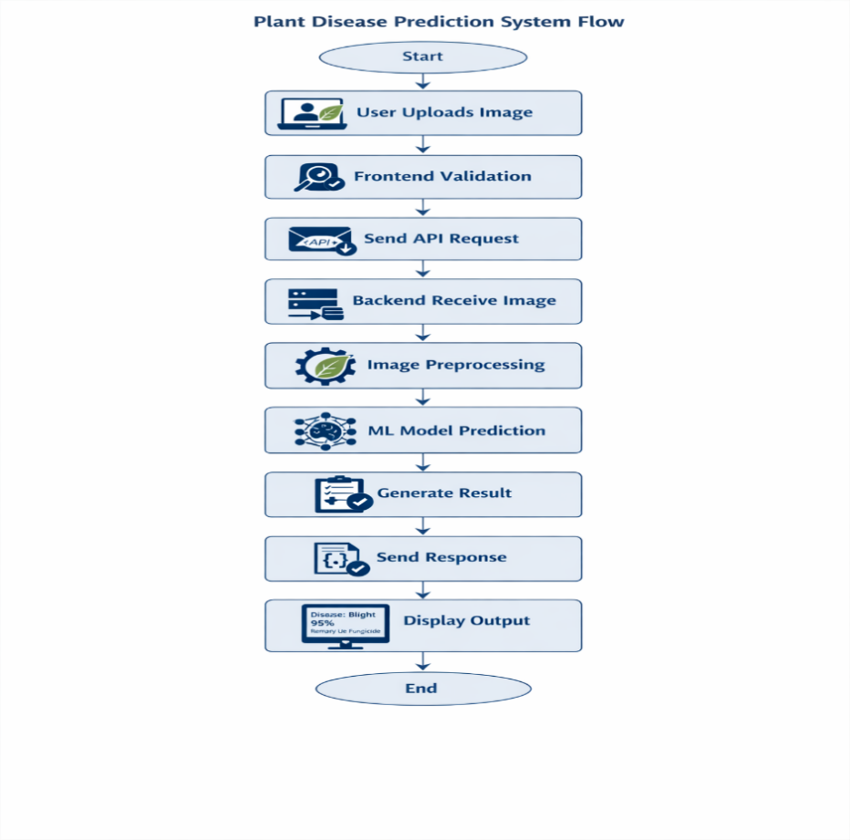
Figure 3.1.1: System Flow of Plant disease Prediction
3.2 Data Flow Diagram
1. DFD Level 0
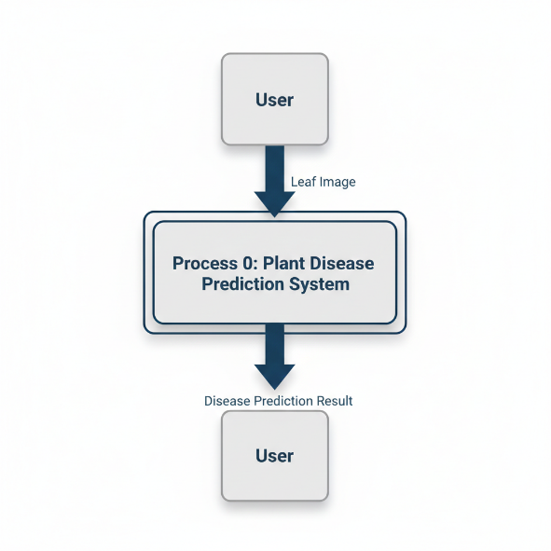
Fig 3.2.1: Data Flow Diagram Level 0

2. DFD Level 1
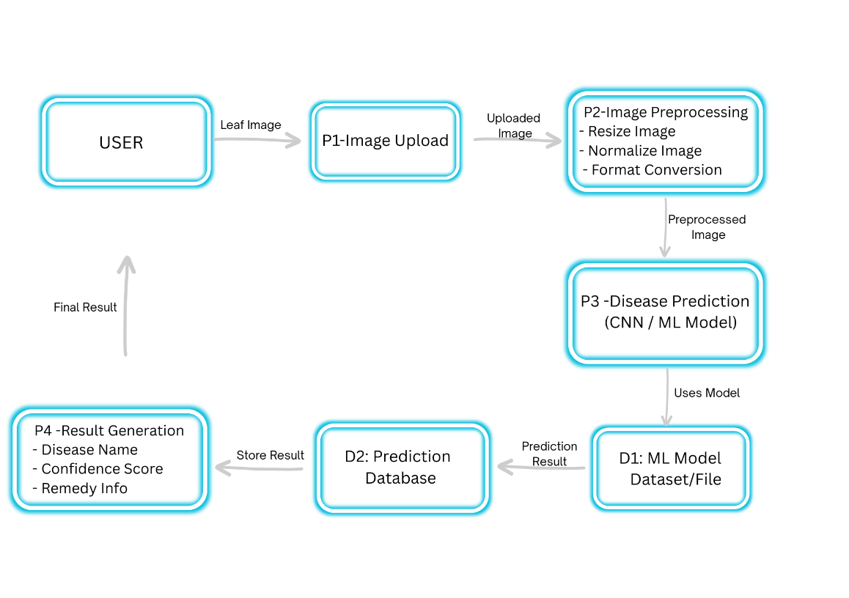
Fig 3.2.2: Data Flow Diagram Level 1

3.3 Use Case Diagram

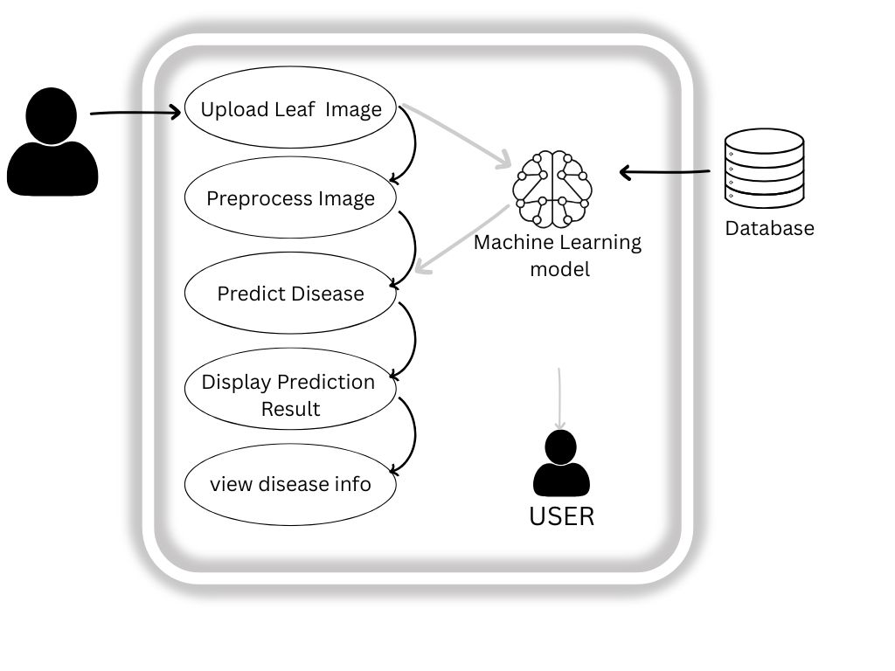
Fig 3.3.1 Use Case Diagram

Chapter 4: Modules
The Plant Disease Prediction System is divided into four primary modules. This modular approach ensures that each component can be developed, tested, and updated independently, which is a standard practice in professional software engineering.

4.1 User Interface (UI) & Image Acquisition Module
This is the entry point of the system. It handles all client-side interactions.
- Functionality: Provides a responsive dashboard for the user to upload or capture a leaf image.
- Key Tasks: * File type validation (ensuring only .jpg, .png, or .jpeg are uploaded).
  - Frontend error handling (notifying the user if the image is too large or corrupted).
  - Asynchronous communication with the backend using the Fetch API or Axios.

4.2 Data Preprocessing & Transformation Module
Raw images from a camera cannot be fed directly into a CNN. This module acts as a "translator" between the user and the AI.
- Functionality: Prepares the raw image for the neural network.
- Key Tasks: * Resizing: Adjusting the image to the standard input size
  - Normalization: Scaling pixel values from to speed up inference and improve accuracy.
  - Array Conversion: Converting the image into a NumPy array or Tensor format.

4.3 CNN Inference & Prediction Module
This is the "Engine" or the "Brain" of the system where the actual Artificial Intelligence resides.
- Functionality: Processes the transformed image to identify the disease.
- Key Tasks: * Model Loading: Initializing the pre-trained weights (e.g., .h5 or SavedModel format).
  - Feature Extraction: The CNN layers identify patterns like spots, discoloration, or wilting.
  - Classification: The final Softmax layer outputs a probability distribution, selecting the class with the highest confidence score.

4.4 Result Generation & Sustainability Advisor Module
This module converts technical data into "Green" actionable insights for the farmer.
- Functionality: Communicates the final result and remedy back to the user.
- Key Tasks: * Mapping: Converting the model's index (e.g., Class 4) to a human-readable name (e.g., Tomato Early Blight).
  - Remedy Retrieval: Fetching organic and sustainable treatment suggestions from a predefined knowledge base.
  - Response Delivery: Sending a structured JSON response to the frontend to update the UI.

Chapter 5: Final Analysis
Output:



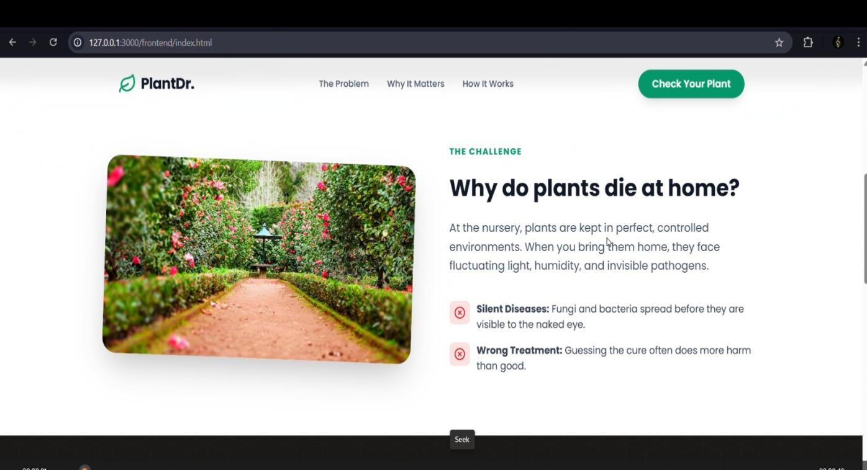

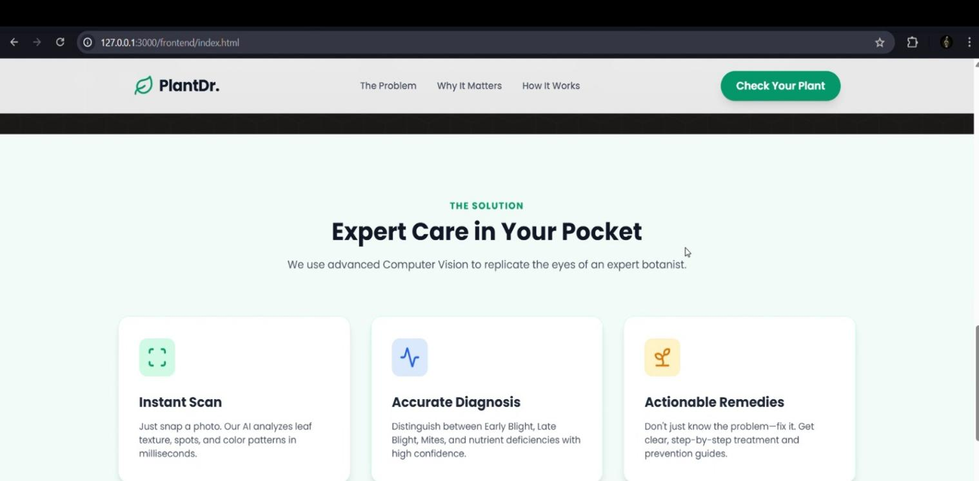

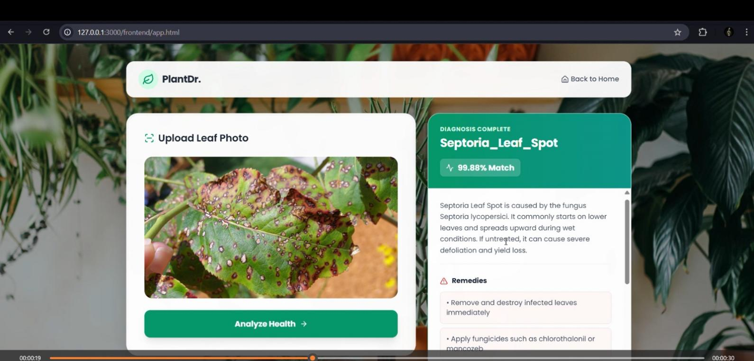

CONCLUSION
The development of the Plant Disease Prediction System represents a significant step toward the integration of Artificial Intelligence into sustainable agricultural practices. This project has successfully demonstrated that deep learning architectures, specifically Convolutional Neural Networks (CNNs), can be effectively deployed to bridge the gap between complex phytopathology and field-level farming.
In conclusion, this project proves that AI is not just a tool for industrial efficiency, but a vital "Green Skill" necessary for building climate-resilient food systems. As we move toward Agriculture 4.0, tools like this will be essential in ensuring global food security while maintaining the ecological balance of our planet.

BIBLIOGRAPHY
- Datasets
- Kaggle – Plant Village Dataset : https://www.kaggle.com/datasets/emmarex/plantdisease/data

Web References
-TensorFlow Documentation – https://www.tensorflow.org
-Keras Documentation – https://keras.io
-Scikit-learn Documentation – https://scikit-learn.org
-Python Official Documentation – https://docs.python.org/3
-NumPy Documentation – https://numpy.org
-OpenCV Documentation – https://opencv.org
3. Related Research:
• Devarajan, D. (2026)
AI-Based Real-Time Disease Diagnosis in Plants Using Deep Learning.
Proposes a deep learning system for real-time plant disease detection to improve crop productivity.
• Ashurov, A. Y. (2025)
Enhancing Plant Disease Detection Through Deep Learning.
Uses improved CNN models for accurate automatic plant disease identification.
4. GitHub Repository Link
- https://github.com/siddhisarode/plant-disease-prediction-ai

